6A^{th} Grade: Unit 7, Lesson 5

- The formula $A= \frac{bh}{2}$ is used to find the area of which shape?

Triangle

- A trapezoid is shown on a grid, with each gridline representing one unit. What is the length of base k on the trapezoid?
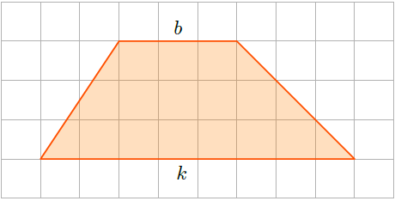

8 units

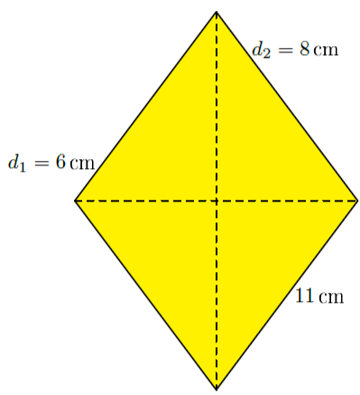
- A rhombus with measurements in centimeters (cm) is shown. Which expression could be used to calculate the area?

$$\frac{1}{2}(6)(8)$$

